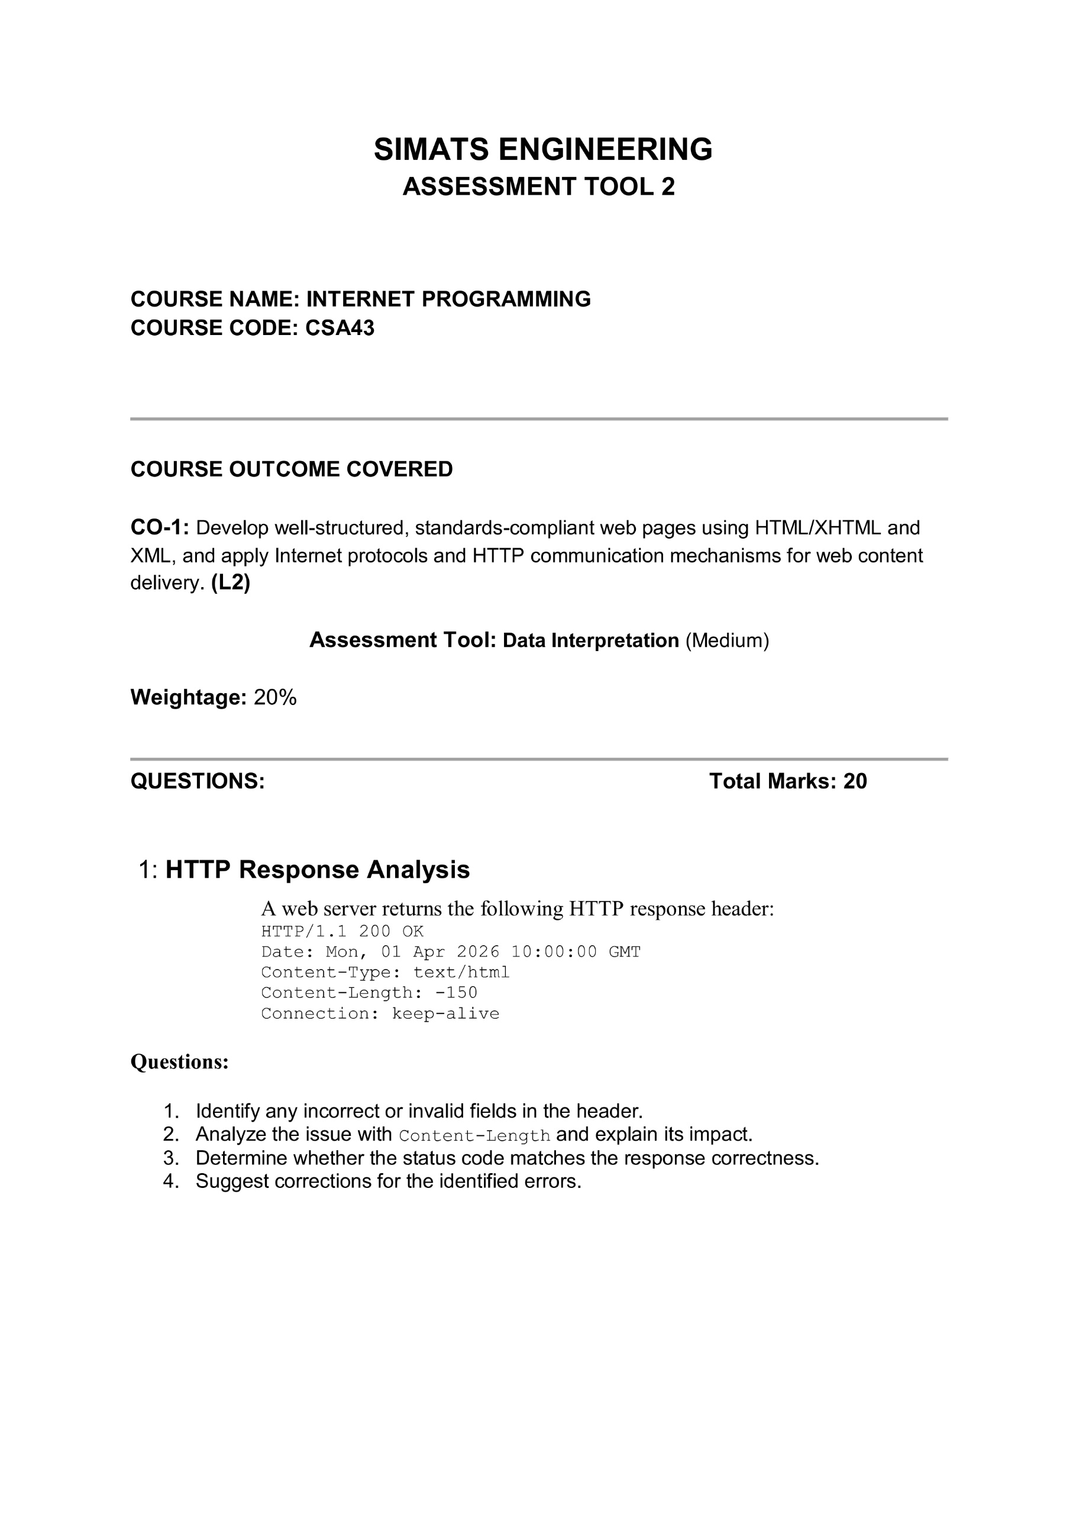
0
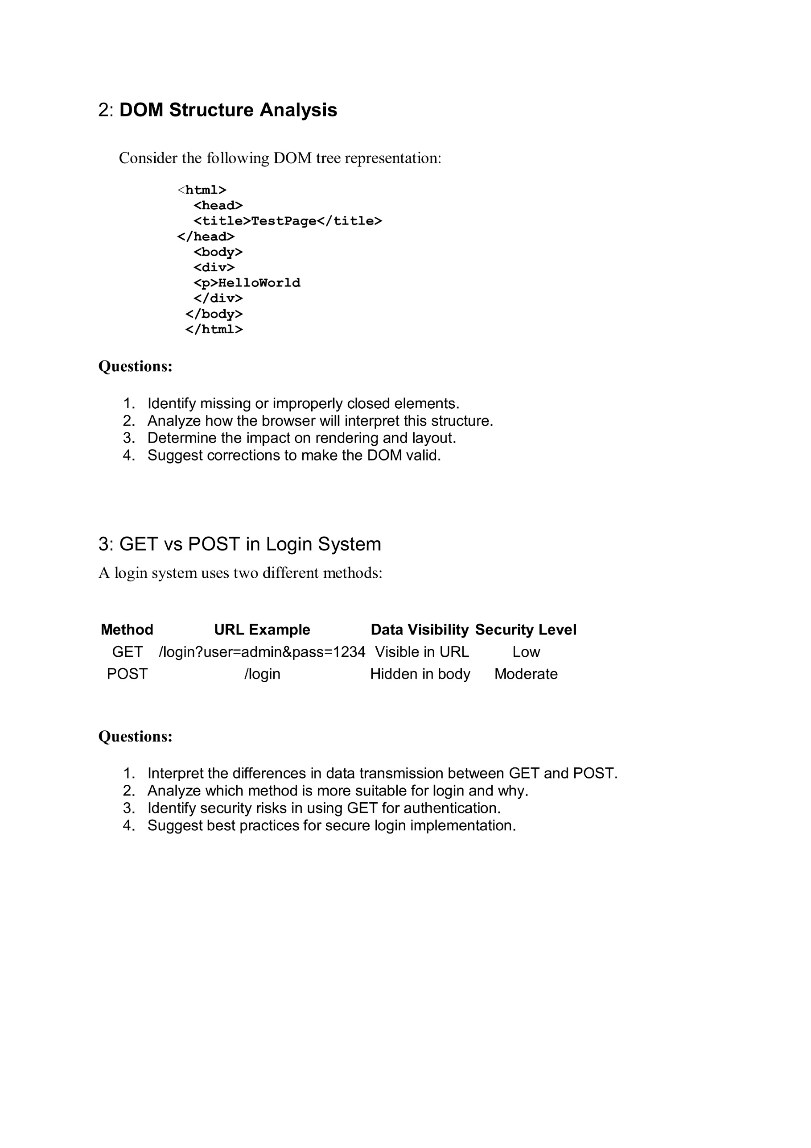

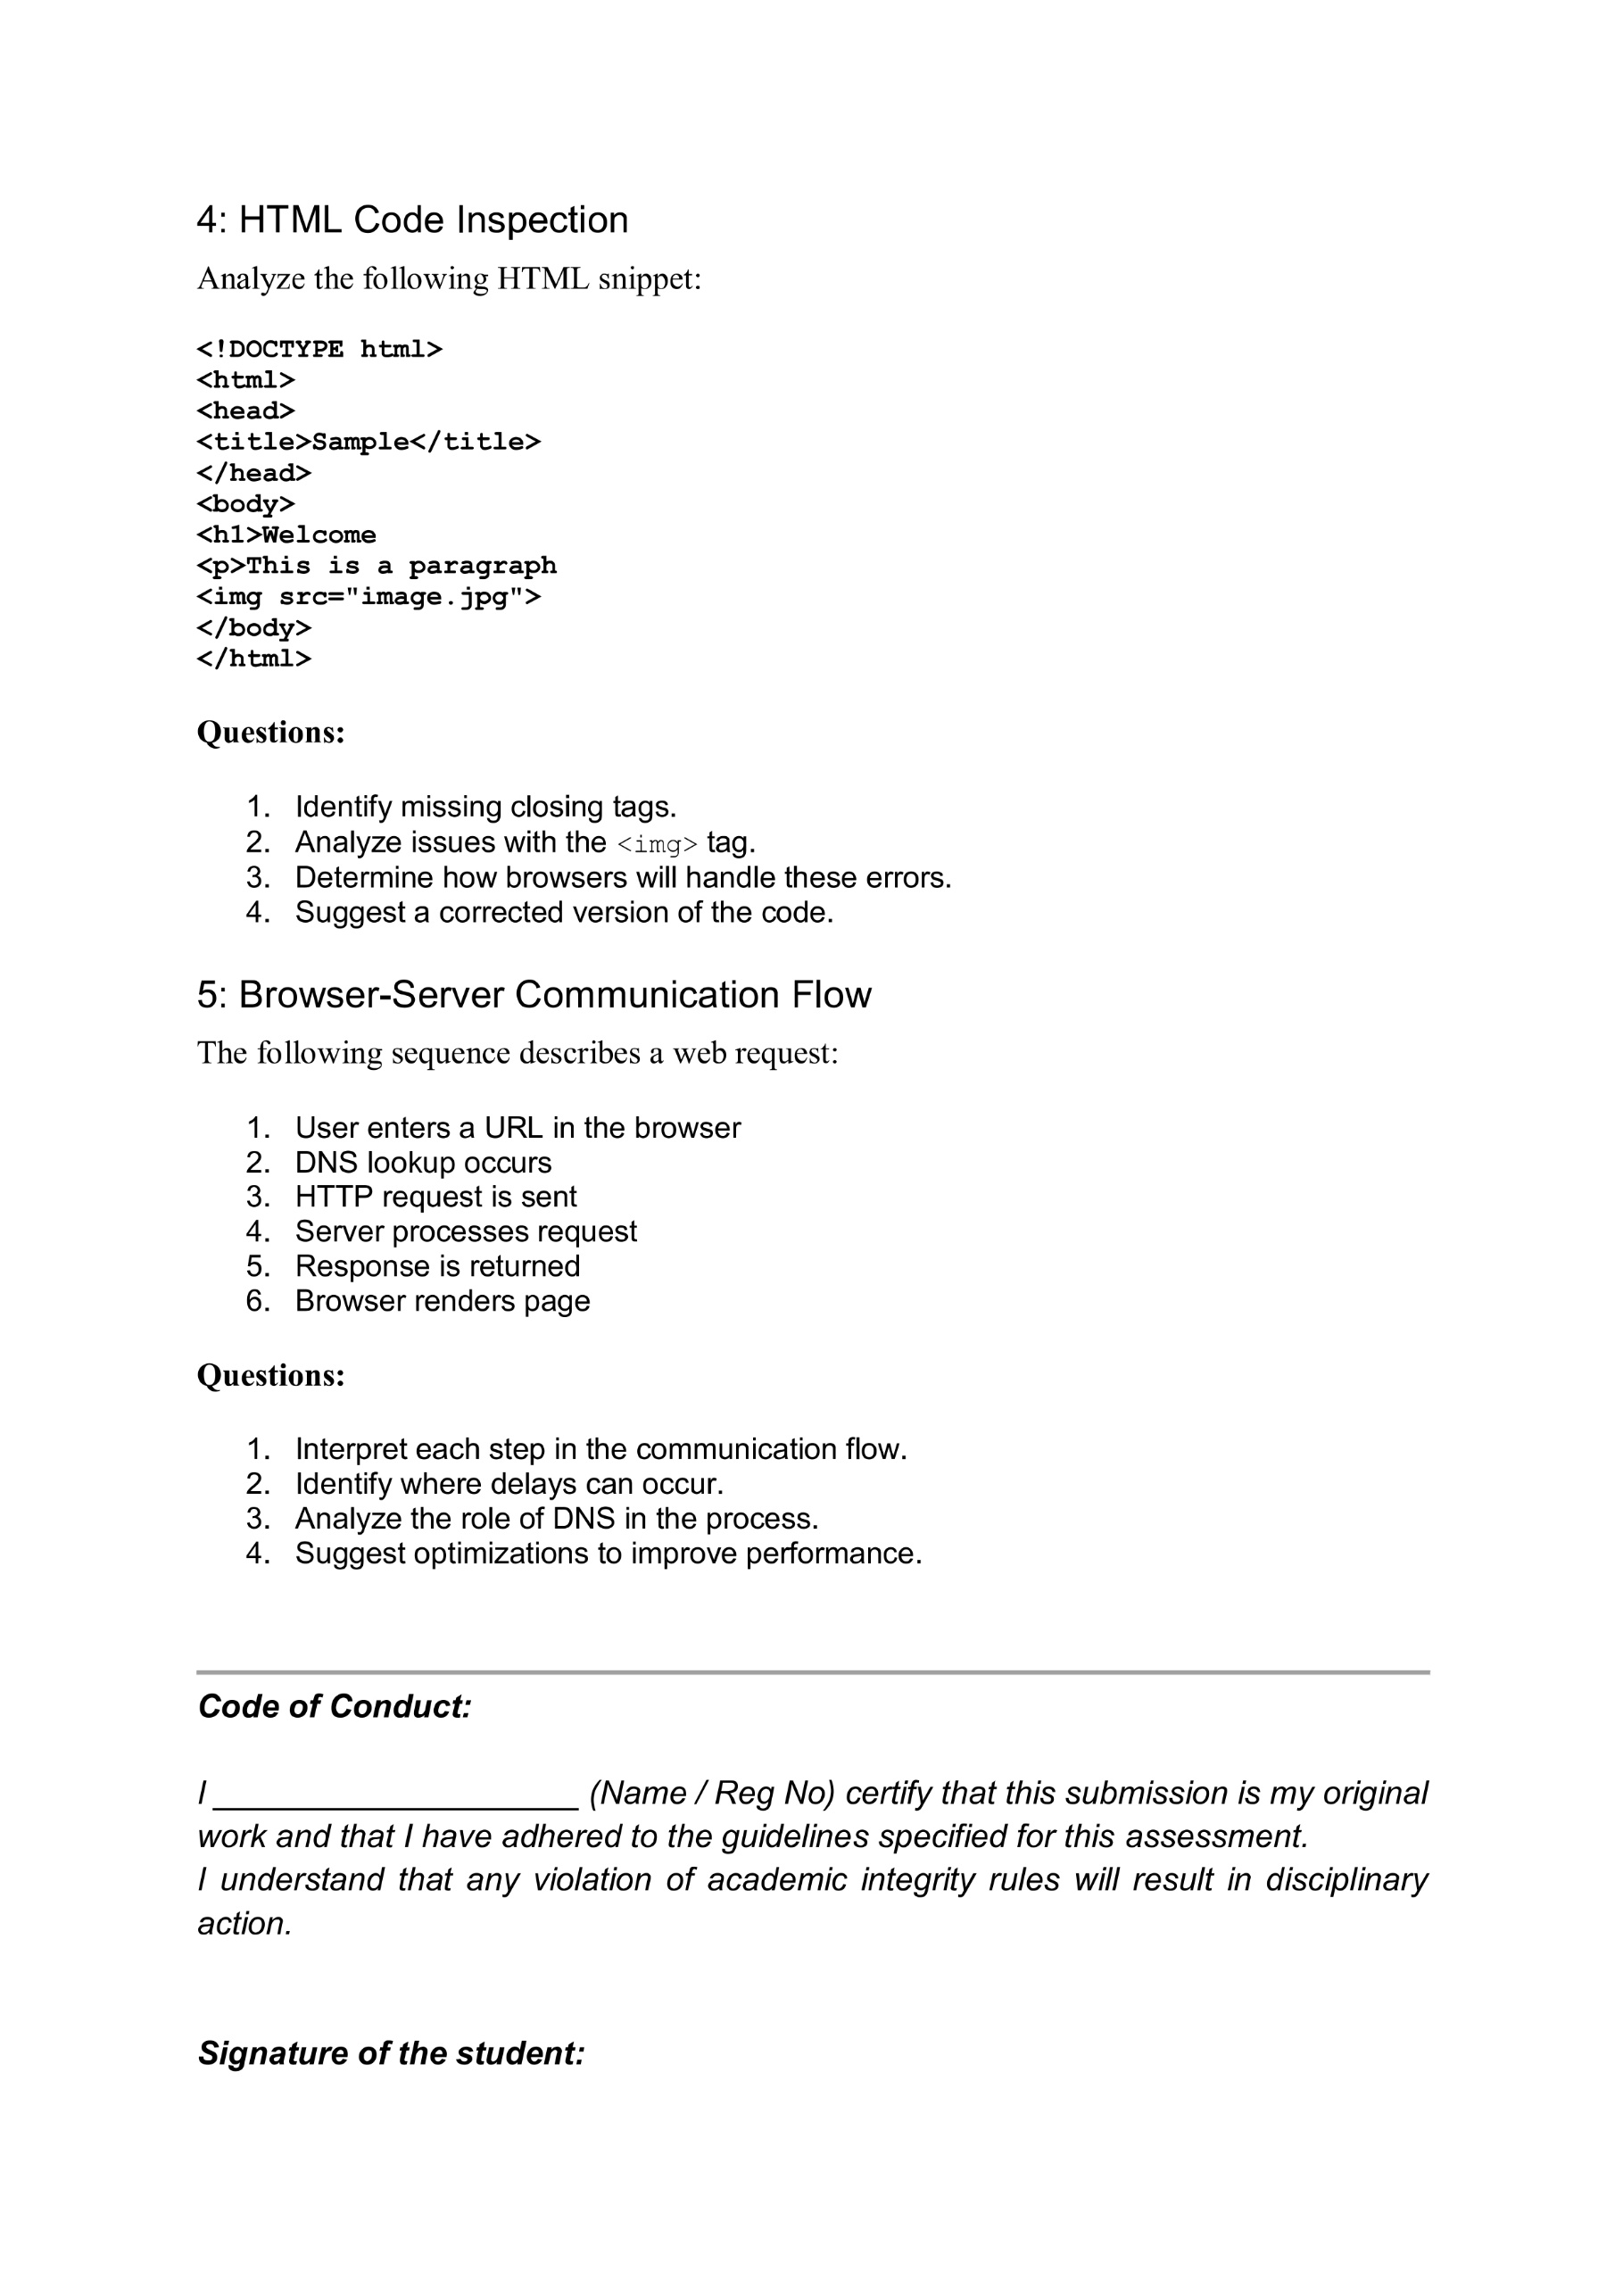

Code of Conduct:

I Dhanush Kumar R (192411215) certify that this submission is my original work and that I have adhered to the guidelines specified for this assessment.I understand that any violation of academic integrity rules will result in disciplinary action.



Signature of the student:
Question 1: HTTP Response Analysis

1. Identify any incorrect or invalid fields in the header.
The response header contains one invalid field:
- Content-Length: -150 (Invalid)
The Content-Length value must always be a positive integer representing the size of the response body. Negative values are not allowed.
The remaining fields (HTTP/1.1 200 OK, Date, Content-Type, and Connection) are valid.

2. Analyze the issue with Content-Length and explain its impact.
The Content-Length header tells the browser the size of the response in bytes.
Using -150 is invalid because content size cannot be negative.
Impact:
- Browser may reject the response.
- Web page may not load correctly.
- Communication between browser and server may fail.

3. Determine whether the status code matches the response correctness.
The status code 200 OK means the request was processed successfully.
However, the response contains an invalid Content-Length value. Therefore, the response is not completely correct, even though the status code is 200 OK.

4. Suggest corrections for the identified errors.
Corrected HTTP header:
HTTP/1.1 200 OK
Date: Mon, 01 Apr 2026 10:00:00 GMT
Content-Type: text/html
Content-Length: 150
Connection: keep-alive
Corrections:
- Replace -150 with a valid positive number.
- Ensure the Content-Length matches the actual response size.
- Validate HTTP headers before sending the response.

Question 2: DOM Structure Analysis

1. Identify missing or improperly closed elements.
The given HTML has the following errors:
- <p> tag is not closed.
- <div> is closed before the <p> tag.
- Proper indentation is missing.
These errors make the DOM structure invalid.

2. Analyze how the browser will interpret this structure.
Most modern browsers automatically correct minor HTML errors while rendering the page.
However:
- The layout may differ across browsers.
- The DOM structure becomes inconsistent.
- It may cause unexpected display or JavaScript issues.

3. Determine the impact on rendering and layout.
The invalid HTML may result in:
- Incorrect webpage layout.
- Inconsistent rendering in different browsers.
- Difficulty in applying CSS styles.
- Problems when accessing elements using JavaScript.

4. Suggest corrections to make the DOM valid.
Correct HTML:
<html>
<head>
<title>TestPage</title>
</head>

<body>

<div>
<p>Hello World</p>
</div>

</body>
</html>
Corrections made:
- Properly closed the <p> tag.
- Maintained correct nesting of elements.
- Improved indentation for better readability.

Question 3: GET vs POST in Login System

1. Interpret the differences in data transmission between GET and POST.
GET | POST
Sends data through the URL. | Sends data in the request body.
Data is visible in the browser URL. | Data is hidden from the URL.
Less secure. | More secure than GET.
Used for retrieving data. | Used for submitting data.

2. Analyze which method is more suitable for login and why.
The POST method is more suitable for login because:
- Username and password are not displayed in the URL.
- It provides better security.
- It supports larger amounts of data.
- It is the standard method for login forms.
Therefore, POST is recommended for user authentication.

3. Identify security risks in using GET for authentication.
Using GET for login has the following risks:
- Username and password are visible in the URL.
- Credentials may be stored in browser history.
- URLs can be bookmarked or shared.
- Sensitive information may be exposed through server logs.
Hence, GET should not be used for login authentication.

4. Suggest best practices for secure login implementation.
- Use the POST method for login forms.
- Enable HTTPS to encrypt data.
- Validate user inputs.
- Store passwords using hashing techniques.
- Use secure session management and authentication.

Question 4: HTML Code Inspection

1. Identify the HTML coding errors.
The given HTML contains the following errors:
- Missing <!DOCTYPE html> declaration.
- Missing <meta charset="UTF-8">.
- Missing <meta name="viewport">.
- Improperly closed or nested HTML tags.
- Missing semantic elements such as <header>, <main>, and <footer>.
These errors make the webpage non-standard and may cause rendering issues.

2. Analyze the impact of these errors.
The coding errors may cause:
- Incorrect webpage layout.
- Different outputs in different browsers.
- Reduced accessibility.
- Difficulty in applying CSS and JavaScript.
- Poor SEO performance.

3. Suggest a corrected HTML structure.
<!DOCTYPE html>
<html lang="en">
<head>
<meta charset="UTF-8">
<meta name="viewport" content="width=device-width, initial-scale=1.0">
<title>Sample Page</title>
</head>

<body>

<header>
<h1>Welcome</h1>
</header>

<main>
<p>Hello World</p>
</main>

<footer>
<p>© 2026 SIMATS Engineering</p>
</footer>

</body>
</html>

4. Recommend best practices for writing HTML code.
- Use HTML5 semantic elements.
- Close all HTML tags properly.
- Maintain proper indentation.
- Validate code using W3C Validator.
- Test the webpage in different browsers.

Question 5: Browser–Server Communication Flow

1. Explain the communication process between the browser and the server.
The communication process follows these steps:
- The user enters a website URL in the browser.
- The browser sends an HTTP request to the web server.
- The server processes the request.
- The server sends an HTTP response back to the browser.
- The browser displays the requested webpage to the user.

2. Analyze the role of HTTP requests and responses.
- HTTP Request: Sent by the browser to request a webpage or submit data to the server.
- HTTP Response: Sent by the server containing the requested webpage, status code, and other information.
Together, they enable communication between the client and the server.

3. Interpret the importance of HTTP status codes.
HTTP status codes indicate the result of a request.
Some common status codes are:
- 200 OK – Request successful.
- 301 Moved Permanently – Resource has been moved.
- 404 Not Found – Requested page not found.
- 500 Internal Server Error – Server encountered an error.
Status codes help users and developers identify the result of a request.

4. Suggest improvements for efficient browser–server communication.
- Use HTTPS for secure communication.
- Compress web resources to reduce loading time.
- Enable browser caching.
- Minimize HTTP requests by combining CSS and JavaScript files.
- Optimize images and other media files.
